RESUME

cAREER OBJECTIVE

To cultivate career with my loyal nature which will also help my organization to reach on highest peak of this world & after creating a unique benchmark I want to see myself on a respectful position in the presence of all you dignitaries.
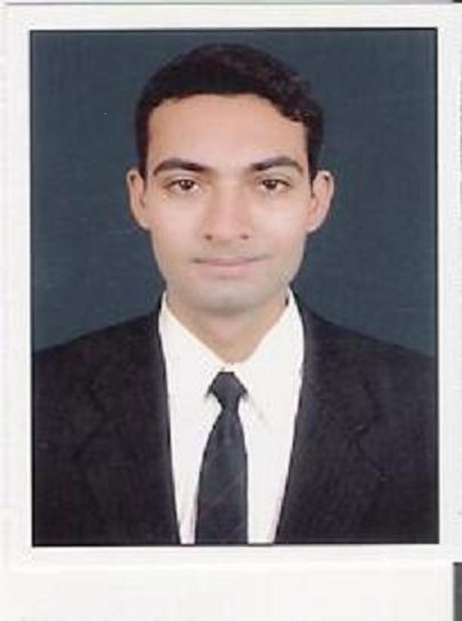
GAURAV.P.MODI

B-86/6, Ashutosh Society No-2, Link Road, Opp.Hdfc Bank, Ta & Di. Bharuch, 392001, State: Gujarat, India.
E-Mail: gauravmodi1984@gmail.com / gauravmodi1984@yahoo.com
Date of Birth: 08th September 1984
Contact: (M) +91-8866688291 / +91- 9427874777

ACADEMIC QUALIFICATION

- Completed MBA (HRM) in Oct-2011 from Sikkim Manipal University with 71%.
- Completed LLB in April-2007 from Veer Narmad South Gujarat University with 54%.
- Completed B.Com (Honors) in April-2005 from Veer Narmad South Gujarat University with 64%.
- Completed HSC (Commerce) in April-2002 from G.S.E.B, Gandhinagar with 72%.
- Completed SSC in March-2000 from G.S.E.B, Gandhinagar with 72%.

SOFTWARE KNOWLEDGE
- Diploma in Computer Application (WHOLE BASIC) with two Languages HTML & VISUAL BASIC 6.0
- TALLY 6.3 &7.2 with A+ Grade.
- Galileo CRS (Consumer Relationship System) Basic & Advance with Distinction.
- Course in Computer Concepts (CCC) Approved by Govt. of Gujarat with A+ Grade.

VOCATIONAL QUALIFICATION

- Diploma in Aviation, Travel Tourism & Hospitality in Sept-2007 from Frank Finn Institute of Aviation Training Center Vadodara with A Grade.

MAJOR PROJECT TITLES DURING ACADEMIC
- Title: Training, Development & Paystructure of An Agents And Employees Of Lic of India.
- Organization: LIC of India, Ankleshwar.
- Status: Project Has been Accepted by University.
- Ultimate Result: As per Central Government’s Latest Pay Structure employees are been moved to Sixth Pay Revision & agents are being paid accordingly.

ACADEMIC ACHIEVEMENTS
- Secured aggregate 1st Class in B.Com (Honours) in V.N.S.G.U.
- Honored with M.R.Thakore Award from M.K.College of Commerce for Scoring Highest Marks in Taxation in the Whole Universitiy in April-2005.
- Honored by Gujarat Typing Board for passing the Gujarat Typing Examination with 40 W.P.M. in English language in April-2000.
- Honored by English Edge Certificate from BBC learning.
EXPERIENCE
- I have worked with Reliance Capital Company (ADAG GROUP) as an Admin Executive for 06 months.
- I have worked with LIC of India ankleshwar for 2.5 years as Recruitment cum Training & Development Officer as Faculty in grade 2.
- Currently Working As an Administration Manager with Waghbakri Tea Process Ltd at Anklehswar.
- Total 5.1 Years Work experience in multiple fields like in Administration,Training & Development,Recruitment & Interviewing.

KEY SKILLS

- TRAINING & DEVELOPMENT
- RECRUITMENT
- INTERVIEWING
- BACK OFFICE
- ADMINISTRATION
- STRETIGIC PLANNING
- TEAM LEADER

LANGUAGES KNOWN
- English
- Hindi
- Gujarati

PREFERRED LOCATION
- Bharuch
- Ankleshwar
- Dahej
- Jhagadia
- Panoli
- Vadodara
- Surat
- Abroad

PERSONAL INFORMATION
- Gender : Male
- Passport No. : G 4997610
- Nationality : Indian
- Personal Skills : Communication Ability, Conceptual Clarity, High Grasping Power,
Self Motivated, Self Confident & always Positive Thinker, Punctuality.
- Weight : 78 Kg
- Religion : Hindu
- Marital Status : Married
- Hobbies : Sports (Cricket, Volleyball, Badminton), Reading,
Listening to Music.
ABILITY
- Always “CAN DO IT & SHALL DO IT” approach.
- Can work in Extreme Pressure.
- Strength to Learn Very Quick.
- Can lead the team & handle whole department independantly.
- Once accept any work, don’t leave it untill it has been completed by me in prescribed time.
- Never loose hope in any type of work.

REFERENCES
- Mr. Jayesh B. Sarang. He is an Account Manager working at L & T LTD, lives in bharuch & his mobile number is 9979766907.
- Mr. Ishan V. Modi. He is an Engineer working at Essar Steel (Hazira) live in Bharuch & his mobile number is 9925241677.

I hereby declare that above information is true and correct to the best of my knowledge.

PLACE : BHARUCH (Your’s Faithfully,)
DATE : 27/12/2012

Gaurav P. Modi

